Dimensional Distinctiveness Constraints on Comparison Processing Across Development

Luc Augier (luc.augier@u-bourgogne.fr)

Université de Bourgogne – LEAD – UMR CNRS 5022

21065 Dijon, France

Jean-Pierre Thibaut (jean-pierre.thibaut@u-bourgogne.fr)

Université de Bourgogne – LEAD – UMR CNRS 5022

21065 Dijon, France

Abstract
We investigated how the benefits of comparisons (within- and/or between- category comparisons) for generalizing novel names for novel objects along a non-salient dimension (texture) might depend on dimensional distinctiveness. We tested 4- and 6-year-olds. We found that in the case of a lower distinctiveness, older children gave more texture-based answers following within-category comparison whereas younger children gave more texture-based answers in between-category comparisons. When distinctiveness was high, both groups benefited from within-comparison. They also benefited from between-category comparison only when within-category comparison were available (i.e. when both kinds of comparison were available). We interpret these findings in terms of differential costs of comparison for varying levels of distinctiveness along either nonsalient or salient dimensions.
Keywords: Comparison, Distinctiveness, Conceptual development, Executive Functions.

Introduction
Acquiring a novel concept requires to find out important diagnostic features and to neglect irrelevant aspects of the stimuli. A major difficulty for children is that in many cases there are irrelevant similarities or differences which are more salient than variations along the relevant features (Murphy, 2004; Gershkoff-Stowe & Rakison, 2005). Hence, understanding what situations help them to favor nonobvious over salient properties is a crucial issue for concept development. In this respect, comparison represents a powerful means for learning about the world (e.g., Gentner & Namy, 1999; Goldstone, 2010; Thibaut, 1991). A growing body of research in both children and adults shows that comparison can highlight nonobvious shared properties (Gentner & Colhoun, 2010). In preschoolers, the benefits of comparison have been shown for object names (e.g., Gentner & Namy, 1999; Graham, Namy, Gentner, & Meagher, 2010), names for parts (Gentner, Loewenstein, & Hung, 2007), adjectives (e.g., Waxman & Klibanoff, 2000), action verbs (e.g., Childers & Paik, 2009; Haryu, Imai, & Okada, 2011), relational nouns (Gentner, Anggoro, & Klibanoff, 2011) or labels for spatial relations (Christie & Gentner, 2010).
In a seminal study, Gentner and Namy (1999) used pictures of objects from familiar taxonomic categories (e.g. fruits) to test 4-year-olds novel names extensions. When only one standard was presented (e.g. an apple labelled blicket) children preferred to extend this new label to a perceptually similar object (e.g. a balloon) rather than to a taxonomically related but perceptually dissimilar object (e.g. a banana). Crucially, this preference was reversed when children were given two standards in comparison (e.g. an apple and a pear, both labelled blicket). With the same paradigm, Graham, Namy, Gentner, and Meagher (2010) also obtained this beneficial effect of comparison with unfamiliar objects. They pitted a perceptually non-salient dimension (texture) against a perceptually salient one (shape). In the no-comparison condition only one standard was presented. There were two test objects, one sharing its texture but not its shape with the standard, the other sharing its shape but not its texture. In this no-comparison situation, a majority of children generalized the novel name to the same-shape transfer object. In the comparison condition, two same-texture standards were introduced with the same label. In this case, a majority of children extended the novel label to the same-texture match. Comparing same-texture items promoted the use of this nonsalient dimension to guide their categorization.
Using the same paradigm (texture against shape), the present study investigated how the effect of comparison might interact with dimensional distinctiveness. Indeed, despite a large body of research on the benefits of comparisons in concept learning, the cognitive constraints generated by comparisons are largely understudied (see Augier & Thibaut, 2013). Our central hypothesis is that different levels of dimension distinctiveness will generate different cognitive costs that might affect performance.

Kinds of Comparisons
Comparison helps preschoolers to find shared non-salient properties for their categorizations. One less investigated, kind of comparison is the comparison between items from different categories (i.e. contrast-category comparison). In preschoolers, contrast had a positive effect on learning subordinate categories (Waxman, Lynch, Casey, & Baer, 1997), proper names (Hall, & Rhemtulla, in press), adjectives for objects properties (Au, & Laframboise, 1990; Waxman & Klibanoff, 2000), perceptual categories (Ankowski, Vlach, & Sandhofer, 2012) or verbs meanings (Childers, Hirshkowitz, & Benavides, in press).
Recently, Namy and Clepper (2010) introduced a condition with a contrast item (e.g., a perceptually similar but taxonomically different light bulb presented as “not a blicket” to contrast with the standards, namely an apple and a pear). They found limited benefits of contrast and only when there was already comparison. However, using multidimensional stimuli, knowing that perceptual similarity was irrelevant did not tell that the correct dimension was taxonomy. Indeed, being told “X is a dax and Y is not a dax” children can infer that featural commonalities (here shape similarity) between X and Y are not sufficient to define what a dax is. However, knowing that one attribute does not discriminate between two categories does not tell which attribute might discriminate them except when the number of attributes defining the categories is very small (see Hammer, Diesendruck, Weinshall, & Hochstein, 2009).

Cognitive Costs of Comparisons
Recently, with the same task as Gentner, and Meagher’s (2010) study, Augier and Thibaut (2013) manipulated the number of items to-be-compared in 4- and 6-year-old children. The underlying hypothesis was that increasing the number of items belonging to the same category would provide more evidence in favor of a unifying, but not salient, dimension (texture). However it would also mean more comparisons to perform and more information to integrate, which would increase the executive costs. They included age as a factor with the hypothesis that increasing the number of items would not be beneficial in the same way at different ages because of executive functions maturation differences. Consistently with their hypothesis, they found that while both groups benefited from comparing two standards, only the older group benefited from an increased number of standards (four standards instead of only two standards). This finding suggests that integrating similarities along a nonobvious dimension comes with executive costs, even though such evidence is converging.
These results are supported by previous findings from analogy tasks (Richland, Morrison, & Holyoak, 2006; Thibaut, French, & Vezneva, 2010). In these studies, the presence of semantic distractors predicted children’s performances. These authors argued that increasing the number of distractors required more inhibition and flexibility capacities to solve the task.

The Present Study
The present study investigates how comparison interacts with the properties of the objects to-be-compared. We manipulated dimensional distinctiveness in the sense that we varied the between object similarity along the shape and the texture dimensions. In the low distinctiveness condition, two textures (or two shapes) were more similar one to the other than in the high distinctiveness condition. In our experiment, noticing the texture similarity among the standards increases the weight of texture to ground category membership while the shape dissimilarity decreases the weight of shape. These similarities and differences would be harder to notice in a low than in a high distinctiveness case because it would require more systematic explorations. Further, we included different age groups (4- and 6- year-olds) in order to manipulate the cognitive resources available to process comparisons. Indeed, given that executive functions develop progressively through childhood (Anderson, 2002), we hypothesized that children of different ages would not benefit from comparison in the same way. In the executive functions context (Andrews & Halford, 2002; Zelazo, Muller, Frye & Marcovitch, 2003), we hypothesized that comparison situations would involve executive costs such as exploring the relations, inhibiting the salient dimension and shifting to the nonsalient dimension. We predicted that the benefits of comparison would be lowered in younger children when the distinctiveness was low because low distinctiveness would generate increased comparison costs.
We also manipulated the available type of comparisons: within-category and/or between-category comparisons. In their study, Augier and Thibaut (2013) manipulated the presence of a shape-contrastive item (a shape-related item as a non-member of the category, i.e. “not a blicket”) and found a positive yet marginal role of contrast for both 4- and 6-year-olds. In the present study we also included a shape-contrastive item. In the case of contrast, the repetition of shape decreases its relevance for category membership. However, children need to use negatively the commonality to reject the shape and look for other diagnostic features, which would require inhibition and flexibility. How will decreasing the distinctiveness along this dimension affect how children make sense of this contrast-category comparison? On one hand, as for the texture similarity among standards, noticing the shape similarity of the contrast item could be harder when differences are more subtle. On the other hand, on the contrary to our comparison situation, the commonality is about the most salient dimension and thus could be less affected by distinctiveness variations.
Finally, we included an experimental condition in which both kinds of comparison were available (i.e. within- and between- category comparisons). How children will integrate the information in this maximally informative condition? The same question arises for the low distinctiveness case in which the relevant information is more difficult to find. Hence, even if the comparison situation provides more information, it might not be necessarily beneficial, depending on how easy are the comparison to process.
We tested 4- and 6-year-old children with four experimental conditions: a baseline No-Compare/No-Contrast condition (one standard and no contrast), a Compare/No-Contrast condition (two standards and no contrast), a No-Compare/Contrast condition (one standard and one contrast) and a Compare/Contrast condition (two standards and one contrast).

Methods

Participants
A total of 240 preschoolers were tested individually at school. We recruited younger children (n= 120, mean age = 53.7m, SD = 3.6, range: 44-59m) and older children (n= 120, mean age = 65.2m, SD = 3.6, range: 60-76m). They were randomly assigned to one of the eight experimental conditions with 15 children per condition. Informed consent was obtained from their school and their parents.

Design
Younger and older groups of children participated in one of eight between-subject experimental conditions resulting from the crossing of the variables Comparison (No Comparison vs. Comparison), Contrast (No Contrast vs. Contrast) and Distinctiveness (Low Distinctiveness vs. High Distinctiveness) (See Figure 1).

Materials
Seven sets of six artificial grey-scale objects pictured on cards were created for each condition of distinctiveness. The dimensions of the cards were 12*9 cm (width*height) and the dimensions of the objects pictured on the cards were approximately 6*6 cm. The objects’ textures and shapes were chosen to be less distinctive in the low distinctiveness condition than in the high distinctiveness condition. This difference was established in adults with overall perceptual similarity ratings ranging from 1 “not similar at all” to 7 “extremely similar”. Different-texture-but-same-shape objects were significantly judged more similar in the low distinctiveness set (M = 4.3) than in the high distinctiveness set (M = 2.2), t(9) = 14.88, p < .001. Different-shape-but-same-texture pairs of objects were also significantly judged more similar in the low distinctiveness set (M = 4) than in the high distinctiveness set (M = 2.2), t(9) = 5.25, p < .01. Textures and shapes used in one trial differed from those used in other trials. The standards shared the same texture but had different shapes. The contrast object in the Compare/Contrast condition had the same shape as one of the standards. One test object, the shape match, had the same shape as one of the two standards (and as the contrast object) but differed in terms of its texture. The other test object, the texture match, had the same texture as the standards (and a different texture than the contrast object). Finally, unrelated test objects (different texture and different shape) were used in a control experiment (see control experiment below) to assess the level of texture-responding when there was no shape match but only a texture match pitted against an unrelated object. Each set was associated with one of seven two-syllable novel names: youma, buxi, dajo, zatu, sepon, xanto, vira

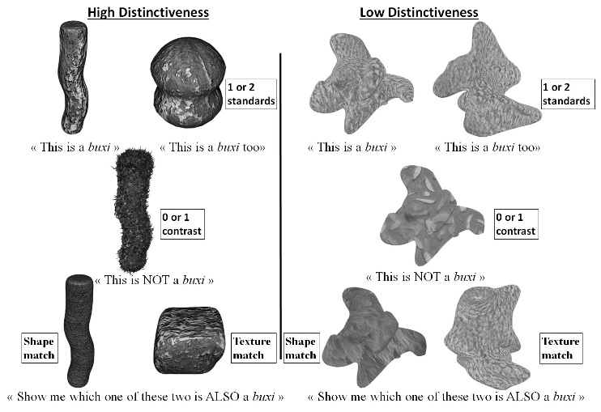

Fig. 1 Sample stimulus sets and instructions used in the eight experimental conditions that crossed the three factors: Comparison (No Comparison or Comparison), Contrast (No Contrast or Contrast) and Distinctiveness (Low or High).

Procedure
The experiment started with two practice trials which were followed by five test trials presented in a random order. Each standard was introduced with a novel count noun (e.g. “this is a buxi” and “this is a buxi TOO” for the other standard). In the contrast conditions, a contrast object was introduced below the standard(s) as a non-member of the category (e.g. “this is NOT a buxi”). The objects were presented sequentially and left in view. In the comparison conditions, stimuli were presented in a row and their location was determined randomly. The forced-choice test phase was identical in all conditions. The two test objects (i.e., the shape and the texture match) were introduced and the child was asked to point to the one which was also a member of the category (e.g., “Show me which one of these two is also a buxi”).

Results
We performed a 2 Age (4 vs. 6-year-olds) x 2 Distinctiveness (high vs. low distinctiveness) x 2 Comparison (1 vs. 2 standards) x 2 Contrast (0 or 1 contrast) ANOVA on the percentage of texture match choices. This analysis revealed significantly more texture-based answers with comparison (20%) than without comparison (60%) (F (1,224) = 103.66, p < .001, ${η }_{P}^{2}$ = .316) and with contrast (46%) than without contrast (35%) (F (1,224) = 7.66, p < .01, ${η }_{P}^{2}$ = .033). Importantly, there was a Comparison by Distinctiveness interaction (F (1,224) = 18.51, p < .001, ${η }_{P}^{2}$ = .076). As shown by Figure 2A, it was due to the larger difference between the No-comparison and Comparison conditions in the high distinctiveness than in the low distinctiveness condition. Tukey post hoc tests revealed that the conditions of distinctiveness significantly differed only in the No-comparison case (31% vs. 10%) and that the benefit of comparison was significant for each level of distinctiveness (31 to 54% for the low, and 10 to 67% for the high distinctiveness conditions).

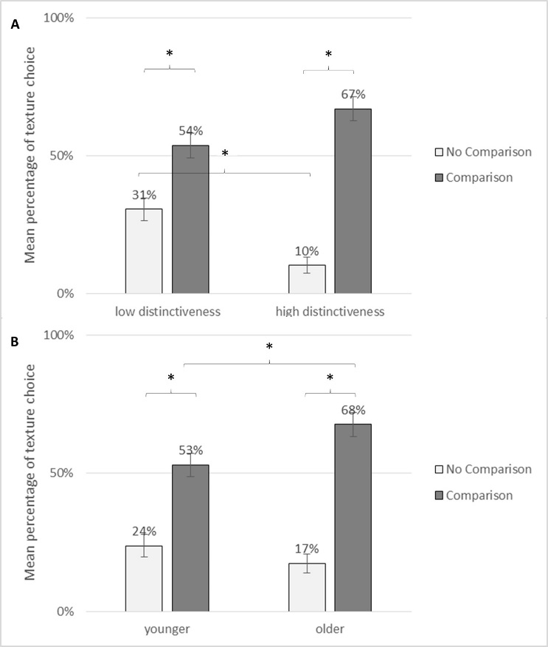

Fig. 2 Mean percentage of texture-based choices (+SEM) as a function of Comparison and Distinctiveness (A) or Comparison and Age (B).

There was an Age x Comparison interaction (F (1,224) = 7.20, p < .05, ${η }_{P}^{2}$ = .008) (see Figure 2B). Tukey post hoc tests revealed that the effect of comparison was significant for both age groups (24 vs. 53% for the younger, and 17 vs. 68% for the older children) but that younger performed lower than older children when there was a comparison (53% and 68% respectively).
Overall, this analysis shows that contrast and comparison promoted more texture-based responding but that the impact of comparison was more important in the high distinctiveness condition, and for older children.
We also ran chi square tests of independence corrected for multiple comparisons (Bonferroni) (p <.05) on patterns of consistency (see Figure 3). Children were categorized as “texture-consistent” when they chose at least four texture matches (out of five) and “shape-consistent” when they chose at least four shape matches. They were “non-consistent” in the other cases. Indeed, a given percentage (e.g., 50%) of texture choices can result from a majority of consistent participants (i.e., 50% shape consistent and 50% texture consistent participants) or from a majority of inconsistent participants.
This analysis shows that, in the high distinctiveness condition and for both conditions of contrast or groups of age, there was significantly more texture-consistency with than without comparison. On the contrary, in the low distinctiveness condition, the superiority of comparison over no-comparison was only present for the older children when there was no contrast (7 to 47%). The age groups were significantly different in the compare/no-contrast condition only (7% for the younger children and 47% for the older children).

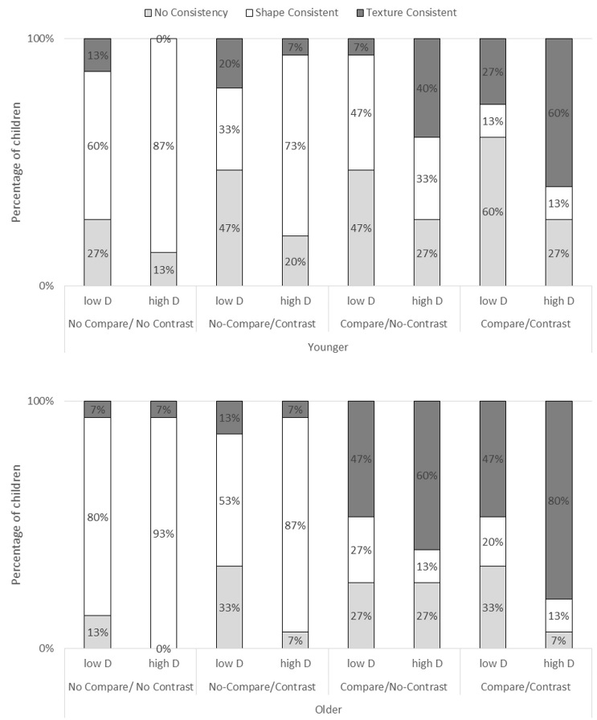

Fig. 3 Percentage of children, for each experimental condition and for each age group, who were either texture consistent, shape consistent, or nonconsistent.

In the high distinctiveness condition, comparison was more powerful for the older children than for the younger children and contrast was equally powerful for both groups (but only powerful when there was already comparison). Further, in the low distinctiveness younger children appeared to be mostly influenced by contrast, and older children mostly influenced by comparison (see Figure 3).

Control Experiment
We also ran a control study with a texture-only condition for both the high and low distinctiveness conditions in order to test whether our results could be explained in terms of texture accessibility differences across distinctiveness levels. To do so, we pitted a texture-related option against an unrelated option to assess texture-responding when texture was the only potential dimensional match.
A total of 60 preschoolers participated in a control experiment: a younger group (n= 30, mean age = 53.8m, SD = 3.2, range: 48-59m) and an older group (n= 30, mean age = 66.5m, SD = 4.2, range: 60-71m). The procedure and materials were identical to the No-Compare/No-Contrast condition except that the shape-match object was replaced by an unrelated item (different texture but also different shape).
We performed a 2 Age (4 vs. 6-year-olds) x 2 Distinctiveness (high vs. low distinctiveness) ANOVA on the percentage of texture match choices. This analysis revealed significantly more texture-responding in older (94%) than younger children (82%) (F (1,490) = 4.4, p < .05, ${η }_{P}^{2}$ = .04) but no differences across distinctiveness levels for either the younger or the older group. Both groups’ performance was above the best conditions in the conditions of the main study. This suggests that the difficulties children met in the low distinctiveness condition were specific to the task of comparing less distinctive items to generalize along the nonsalient texture dimension.

Discussion
We studied how dimensional distinctiveness would interact with age in comparison and no comparison conditions. We hypothesized that manipulating distinctiveness would differentially tax cognitive processing in children of different ages. With the same purpose, we also used various comparison conditions.

Dimensional Constraints on Comparisons
Consistently with our hypothesis, we found that within-category comparison interacted with the “cognitive costs” variables (distinctiveness and contrast) and cognitive resources (manipulated with the age factor). Both groups could benefit from comparison when the distinctiveness was high but only the older children could when the distinctiveness was low. We interpret this finding in terms of higher executive costs to integrate nonobvious commonalities when the differences are more subtle.
In the low distinctiveness condition, patterns of consistency suggest that younger children were mostly influenced by contrast (benefiting from contrast in both No-Comparison and Comparison conditions). This result suggests that when the nonsalient dimension is not very distinctive, younger children would focus on the most salient dimension at hand. Contrast was less important for the older group, possibly because they processed both texture and shape variations and did less focused on shape.
In the high distinctiveness condition both groups benefitted from comparison but neither groups from the contrast item in the No-Comparison condition, even though shape was more distinctive. This result could suggest that in this case, not only the older but also the younger could notice commonalities and differences along both the shape and the texture, and therefore needed to handle both dimensions. However, when there was comparison, both groups benefitted from an additional contrast item. In this case, the contrast item would have played a confirmatory role in the sense that comparison already helped children to find out the texture commonality among the standards. The additional contrastive item could then have played the role to confirm that shape was irrelevant and texture was acceptable. However, this confirmatory role of contrast was probably harder to process in the low distinctiveness condition, which could explain why the older children did not benefit from the contrast in the compare/contrast condition when the distinctiveness was low. Indeed, the challenge of handling both kinds of categorical information would have been strengthened in this situation. When both sources are available, children need to interpret similarities or differences in opposite ways (i.e. within-category commonalities lead to choose the common texture dimension whereas between-category commonalities lead to the rejection of the common shape dimension). As similarities and differences, along both dimensions, were more subtle in the low distinctiveness condition, it was probably harder to process categorical cues in separate and opposite ways.

Conclusion
Our study shows that the distinctiveness of properties which are involved in comparisons interacts with development, arguably because of executive capacities differences. This information integration costs mirror the findings by Augier & Thibaut (2013) who showed that more items to-be-compared was differentially beneficial to younger and older children. In the present study, we first found that comparing shared nonsalient properties generates cognitive costs which are more important when the distinctiveness is low. Distinctiveness also impacted the use of contrasting information but in an indirect way. Indeed, the costs of processing salient commonalities are probably less sensitive to distinctiveness variations, but the use of contrastive information also depends on how other dimensions are processed and how categorical information might compete. These findings have important implications about the role comparisons play in learning. The executive constraints on comparison processing might explain under which conditions comparisons can or cannot be fruitful, and which kind of categorical comparisons could be effectively used.

Acknowledgments

The authors wish to thank the Conseil Régional de Bourgogne for its financial support (PhD grant to the first author), Faber Program and from the ANR Anafonex grant (ANR-10-BLAN-1908) to the second author. We thank the children, their parents and the school staff for participating.

References
Anderson, P. (2002). Assessment and development of executive function (EF) during childhood. Child Neuropsychology, 8(2), 71-82.
Andrews, G., & Halford, G. S. (2002). A cognitive complexity metric applied to cognitive development. Cognitive psychology, 45(2), 153-219.
Ankowski, A. A., Vlach, H. A., & Sandhofer, C. M. (2013). Comparison Versus Contrast: Task Specifics Affect Category Acquisition. Infant and Child Development, 22(1), 1–23.
Au, T. K. F., & Laframboise, D. E. (1990). Acquiring color names via linguistic contrast: The influence of contrasting terms. Child Development, 61(6), 1808-1823.
Augier, L., & Thibaut, J. (2013). The benefits and costs of comparisons in a novel object categorization task: Interactions with development. Psychonomic Bulletin & Review, 20(6), 1126–32.
Childers, J. B., Hirshkowitz, A., & Benavides, K. (in press). Attention to Explicit and Implicit Contrast in Verb Learning. Journal of Cognition and Development.
Childers, J. B., & Paik, J. H. (2009). Korean-and English-speaking children use cross-situational information to learn novel predicate terms. Journal of Child Language, 36(01), 201-224.
Christie, S., & Gentner, D. (2010). Where Hypotheses Come From: Learning New Relations by Structural Alignment. Journal of Cognition and Development, 11(3), 356–373.
Gentner, D., Anggoro, F. K., & Klibanoff, R. S. (2011). Structure mapping and relational language support children’s learning of relational categories. Child development, 82(4), 1173–88.
Gentner, D., Loewenstein, J., & Hung, B. (2007). Comparison facilitates children’s learning of names for parts. Journal of Cognition and Development, 8(3), 285–307.
Gentner, D., & Colhoun, J. (2010). Analogical processes in human thinking and learning. In B. Glatzeder, V. Goel, & A. von Müller (Vol. Eds.), On Thinking: Vol. 2. Towards a Theory of Thinking, pp 35–48. Berlin: Springer-Verlag.
Gentner, D, & Namy, L. L. (1999). Comparison in the development of categories. Cognitive Development, 14(4), 487–513.
Gershkoff-Stowe, L., & Rakison, D. H. (Eds.). (2005). Building object categories in developmental time. Psychology Press.
Goldstone, R. L., Day, S. & Son, J. Y. (2010). Comparison. In B. Glatzeder, V. Goel, & A. von Müller (Vol. Eds.), On Thinking: Vol. 2. Towards a Theory of Thinking, pp 103–122. Berlin: Springer-Verlag.
Graham, S. A., Namy, L. L., Gentner, D., & Meagher, K. (2010). The role of comparison in preschoolers’ novel object categorization. Journal of experimental child psychology, 107(3), 280–90.
Hall, D., & Rhemtulla, M. (in press). Young Children’s Use of Contrast in Word Learning: The Case of Proper Names. Journal of Cognition and Development.
Hammer, R, Diesendruck, G., Weinshall, D., & Hochstein, S. (2009). The development of category learning strategies: What makes the difference? Cognition, 112(1), 105–119.
Haryu, E., Imai, M., & Okada, H. (2011). Object Similarity Bootstraps Young Children to Action‐Based Verb Extension. Child Development, 82(2), 674-86.
Murphy, G. L. (2004). The big book of concepts. MIT press.
Namy, L. L, & Clepper, L. E. (2010). The differing roles of comparison and contrast in children’s categorization. Journal of Experimental Child Psychology, 107(3), 291–305.
Namy, L. L., & Gentner, D. (2002). Making a silk purse out of two sow’s ears: Young children's use of comparison in category learning. Journal of Experimental Psychology-General, 131(1), 5–15.
Richland, L. E., Morrison, R. G., & Holyoak, K. J. (2006). Children’s development of analogical reasoning: Insights from scene analogy problems. Journal of Experimental Child Psychology, 94(3), 249-273.
Thibaut, J.P. (1991). Récurrence et variations des attributs dans la formation de concepts. Unpublished doctoral thesis, University of Liège, Liège.
Thibaut, J. P., French, R., & Vezneva, M. (2010). Cognitive load and semantic analogies: Searching semantic space. Psychonomic bulletin & review, 17(4), 569-574.
Waxman, S. R., & Klibanoff, R. S. (2000). The role of comparison in the extension of novel adjectives. Developmental Psychology, 36(5), 571–581.
Waxman, S. R., Lynch, E. B., Casey, K. L., & Baer, L. (1997). Setters and samoyeds: The emergence of subordinate level categories as a basis for inductive inference in preschool-age children. Developmental Psychology, 33(6), 1074–1090.
Zelazo, P. D., Muller, U., Frye, D., & Marcovitch, S. (2003). The development of executive function in early childhood. Monographs of the Society for Research in Child Development, 68(3), Serial No. 274.

