Perceptual influences in graphics processing
Jean-Michel Boucheixª, & Richard. K. Lowe ^{a,b}
ªLEAD-CNRS, University of Bourgogne Franche-Comté, Dijon France
^{b}Curtin University, Perth, Australia
Jean-Michel.Boucheix@u-bourgogne.fr

Introduction and Theoretical Background
This theoretical paper identifies possible sources of perceptual influence in the processing of both static and dynamic graphics that, if not sufficiently taken into account, potentially compromise learning from multimedia resources. These possibilities are illustrated here by considering example graphic material (i.e., a piano mechanism, Figure 1) used in the authors’ previous research. Further examples based on different content will be given during the conference presentation. Although discussion in this paper draws on well-established visual perception research, it specifically targets the actual types of graphic materials used in educational multimedia rather than the highly specialized graphics typically employed in that more fundamental research. Our motivation is that to date, multimedia research has largely neglected the substantial role that the perceptual features of multimedia’s graphic components may play in the overall effectiveness of such resources. The dominant emphasis has instead been on issues concerning how different media types (e.g., text and graphics) might best be combined to foster effective learning. (e.g., Mayer, 2005).

The Perceptual System
Visual information gathering is constrained by the characteristics of humans’ basic perceptual equipment. For detailed analytical processing, we primarily rely on the small fraction of our available visual field that is covered by foveal vision. Beyond this limited range, peripheral vision is available and although it covers more of the visual field, it is more restricted in terms of information extraction (Rosenholtz, 2016). With a static piano mechanism display, comprehensive interrogation necessarily involves a series of distributed fixations in which attention is devoted in turn to different aspects of the mechanism. Peripheral vision can collect more holistic information for guiding these fixations in a systematic, strategic manner. Because the content is relatively complex, this perceptually-based exploration inevitably takes a finite amount of time. This has possible implications for the pacing of multimedia materials in general; if system-controlled pacing is too fast, learner extraction of information that is crucial raw material for subsequent cognitive processing could be compromised. Things are likely to be even more challenging with the animated version because of its transience. The difficulties learners face in extracting essential information from conventionally-designed animations and has prompted research to find alternative approaches to animation design. (e.g., Lowe & Boucheix, 2016).
Attending to and Linking Information
Information search and Gestalt psychology are important visual perception research areas with likely implications for multimedia graphics. Taking the piano mechanism example again, its component entities vary in fundamental aspects such as size, shape, orientation etc. These and other attributes (including colour and motion) can influence which elements in a display are likely to be attended to and which neglected (Wolfe & Horowitz, 2004). Hence in a static piano mechanism, some components (such as the large, distinctively shaped and angled hammer) are more visually salient and so more likely to be noticed than others (such as the small, unremarkable, vertically-oriented spoon). Unfortunately, item salience does not necessarily correspond with relevance so extraction of the required information can be compromised. One of the most widely applicable Gestalt principles is that of Proximity whereby items that are close together in space (or time) tend to be perceived as more strongly related than widely separated items (Wagemans, 2015). For the piano mechanism example, perceptual grouping by proximity is perhaps a two-edged sword. On the positive side, the key (lower right, Figure 1) should indeed be grouped with its close neighbor (the whippen) because they are also functionally related. However, on the negative side, the hammer which is far more distant from the key is actually intimately related to it in a functional sense (when you press a piano key, the corresponding hammer strikes the string to produce the required musical note). In this case, there is conflict between perception and functionality. For animated displays, the situation can actually be worse because of inappropriate attention capture by movement, and failures to group related event units due to conflict with the Gestalt principle of Common Fate. Examples of both will be given in the conference presentation.
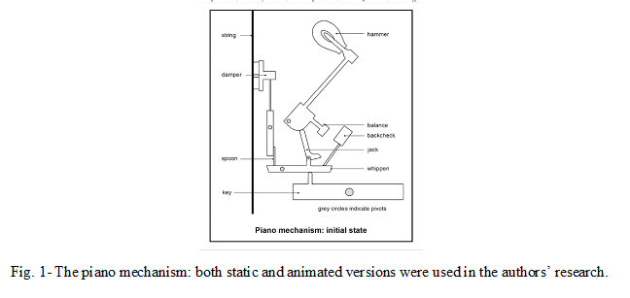

Individual Differences in Perception
Discussion thus far has focused on some fundamental characteristics of visual perception without addressing differences amongst individual learners regarding perceptual capacities. However, it is clear that learners vary greatly in this regard and these differences tend to be correlated with performance on higher level tasks involving the processing of graphic displays. The notion of Dynamic Spatial Ability (Sanchez & Wiley, 2014) appears to be particularly relevant to what learners encounter when studying an animated version of the piano mechanism. Some participants were found to misattribute the Hammer’s projection towards the string as being due to a Balance-Backcheck collision, rather than to identify the correct cause (a push from the Jack). This could perhaps be due in part to them having low levels of dynamic spatial ability.
Conclusion
In this extended summary, we used the example of piano mechanism graphics to suggest ways in which perceptual issues could ultimately influence how effectively individuals may process the types of graphics typically found in multimedia learning resources. Ideas canvassed in this introductory presentation will be taken up in more detail by subsequent contributors to the proposed symposium.

References
Lowe, R.K., & Boucheix, J-M. (2016). Principled animation design improves comprehension of complex dynamics. Learning and Instruction, 45, 72-84.
Mayer , R.E. (Ed.). (2005). The Cambridge Handbook of Multimedia Learning. New York: Cambridge University Press.
Rosenholtz, R. (2016). Capabilities and limitations of peripheral vision. Annual Review of Vision Science, 2, 437-457
Sanchez, C.A., & Wiley, J. (2014). The role of dynamic spatial abilities in geosciences text comprehension. Learning and Instruction, 31, 33-45.
Wagemans, J. (Ed.) (2015). The Oxford Handbook of Perceptual Organization. Oxford: Oxford University Press. Berlin: Springer.
Wolfe, J.M., Horowitz, T.S. (2004). What attributes guide the deployment of visual attention and how do they do it? Nature Reviews Neuroscience, 5, 1-7.

